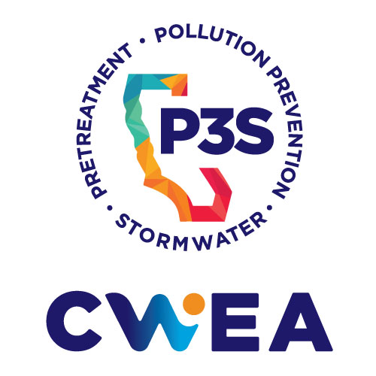 | 2023-2024  P3S SPECIAL PROJECT GRANT APPLICATION

INSTRUCTIONS
- Use this form to apply for a Project Grant from the Pretreatment, Pollution Prevention, and (P3S) Stormwater Committee, a Committee of the California Water Environment Association (CWEA).
- Save and submit the application as a .pdf file. If desired, attach an additional one-page project narrative and up to five additional pages of supporting documentation (also saved as .pdf files).
- Submit your application via email to p3s.cwea@gmail.com by December 29, 2023.
- An agency/district may submit more than one application.
- The applications are reviewed and approved by the P3S Executive Committee. The Committee plans to award a total of $5,000 distributed in two to five grants, in the range of $500 to $2,500 each. The grant is intended to plant a seed; we know it may not be enough to support your entire project. To this end, we strongly encourage community partnerships. Whether your agency partners with a non-profit, a school or another group, we believe that these relationships can leverage and further the clean water message. Be creative as you consider how you can reach more people through community partnerships.
- All applicants will be notified of their status by January 22, 2024. Instructions for grant disbursement will be provided to grantees at that time. All check requests must be submitted by June 30, 2024. Grantees are encouraged, but not required, to make a 2-3 min presentation on their project at the 2024 P3S Conference.
- Questions? Contact Jason Finn, P3S Grants Coordinator, at jfinn@lacsd.org

PROJECT SPONSOR / CONTACT

Contact name:

Agency:

Address:

Phone: Email:

CWEA Sponsor (if different from above):

Sponsor name:

PROJECT DESCRIPTION

Project Title:
Brief description of project:

Time frame start and finish:
Explain project goals/ objectives/ expected results:

In what way(s) does this project support the P3S Committee mission? See https://p3s.cwea.org/about/

Explain why grant funds are needed. Please understand that the Committee may not be able to fully-fund each project. Let us know whether the project can still be (partially or fully) implemented if not fully funded by P3S.

Create a budget of how you will expend the grant funds, including quotes for materials or services if applicable. Attach this information or summarize it in the table below.
Project Expenses | Grant Funds
Office Supplies/Postage
Printing/Publications
Equipment/Hardware
Professional Services
Other (use lines below to identify additional expenses not specified above):
Total Expenses

EXAMPLES OF PAST PROJECT WINNERS
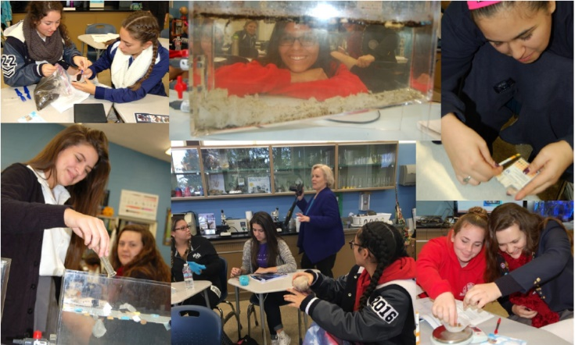
City of LA Sewer Science Teacher Training
‘Sewer Science’ is a 5-day in-classroom workshop on wastewater treatment. Through this grant, the City was able to run teacher-training workshops to prepare LA Unified School District teachers to make Sewer Science part of their curriculum.
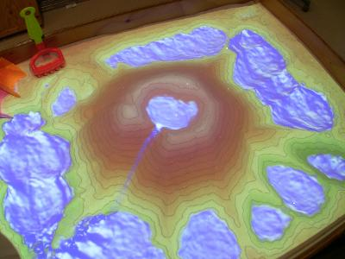
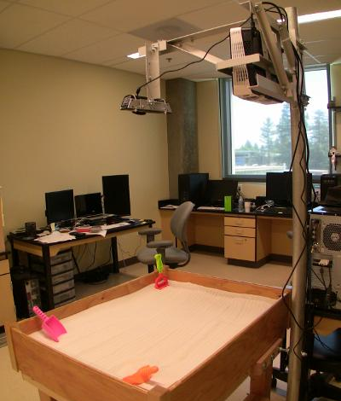
Southern Orange County Wastewater Authority
Watershed Model Sandbox
Through the P3S Grant, SOCWA acquired materials and equipment to build a ‘Watershed Model Sandbox’. This interactive tool lets users create their own watershed in a sandbox – with topography and waterway images superimposed by a digital projector. The model is a powerful education tool.
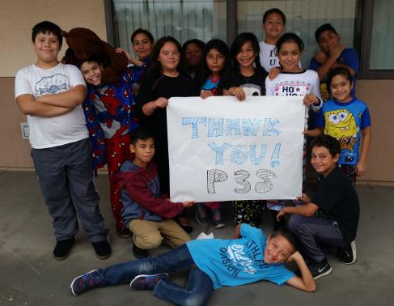
Chaparral Hills Elementary Water Education Program
The P3S Grant supported several water-education activities at this elementary school. The students participated in a school assembly with Shows That Teach and their education program Where did the water go? Grades 3-5 also went on a field trip to the Chino Basin Water Conservation District. In addition, the school organized a Water Conservation night for students and parents and educated attendees on low-flow water nozzles, shower heads, rain barrels, and other ways to facilitate water conservation at home.
Surfrider Foundation (Newport Beach Chapter) Ocean Friendly Restaurant Program
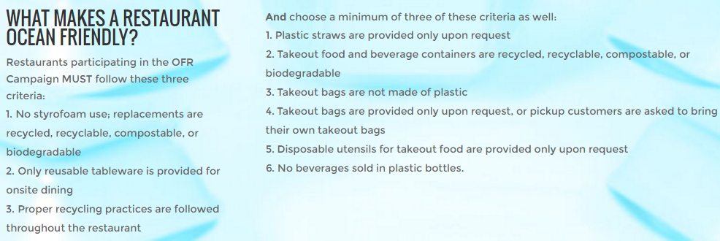
The P3S Grant supported the Ocean Friendly Restaurant Program which promotes environmentally-friendly restaurant practices to reduce trash in our water ways. Surfrider strives to involve student volunteers from local high-schools in the OFR Program. This is a win-win-win for pollution prevention education: students, restaurants, and municipalities all benefit.
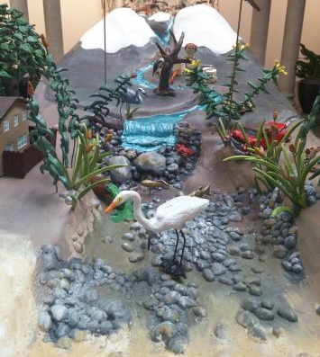
Riverside Art Museum The Art of Water Protection
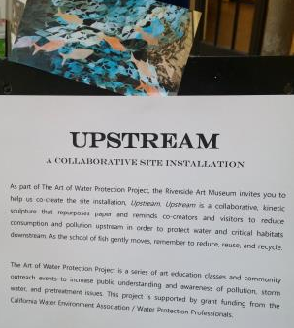
Through the ART of Water Protection series, the Riverside Art Museum organized art education and community outreach projects to increase public understanding and awareness of water protection issues. The series was held in conjunction with Earth Day celebrations and included a walk up Mt Rubidoux (a Riverside landmark) led by members of the Santa Ana River, Inland Empire Waterkeeper, and CWEA. The museum also ran a Water-Inspired Eco Exhibit, including a Santa Ana River Diorama.
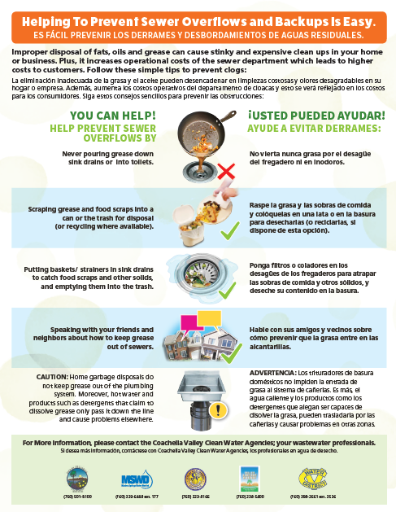
City of Coachella Coachella Valley-Wide FOG Outreach Program
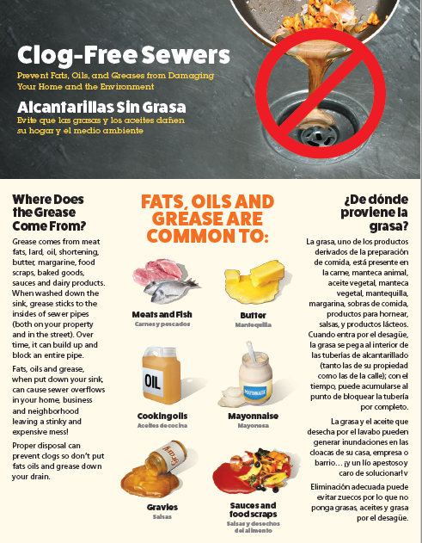
The P3S Grant assisted the City of Coachella in developing a regional Fats, Oil and Grease (FOG) residential outreach program. FOG is a major environmental problem in the Coachella Valley. By establishing a Valley-wide program, the Coachella Valley POTWs created a consistent message that informs residents of the impact FOG has on the environment.

